**SAVEETHA SCHOOL OF ENGINEERING**

**SAVEETHA INSTITUTE OF MEDICAL AND TECHNICAL SCIENCES DEPARTMENT OF COMPUTER SCIENCE AND ENGINEERING**

**Academic Year 2022-23**

**List of Programs**

**Course Code –CSA03 Course Name - DATA STRUCTURES**

|  |  |
| --- | --- |
|  | **PROGRAMS** |

**Exam oriented programs**

1. **Reversing a 32 but signed intergers**

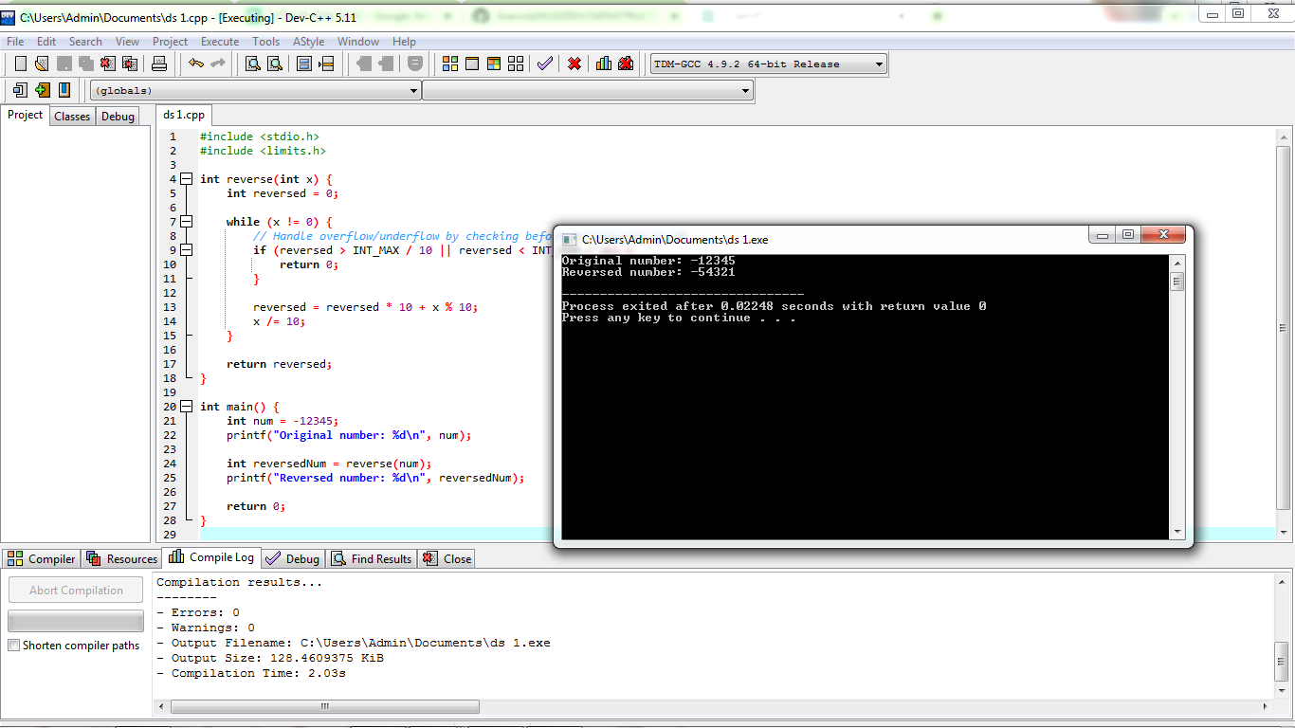

1. **Check for a valid String**

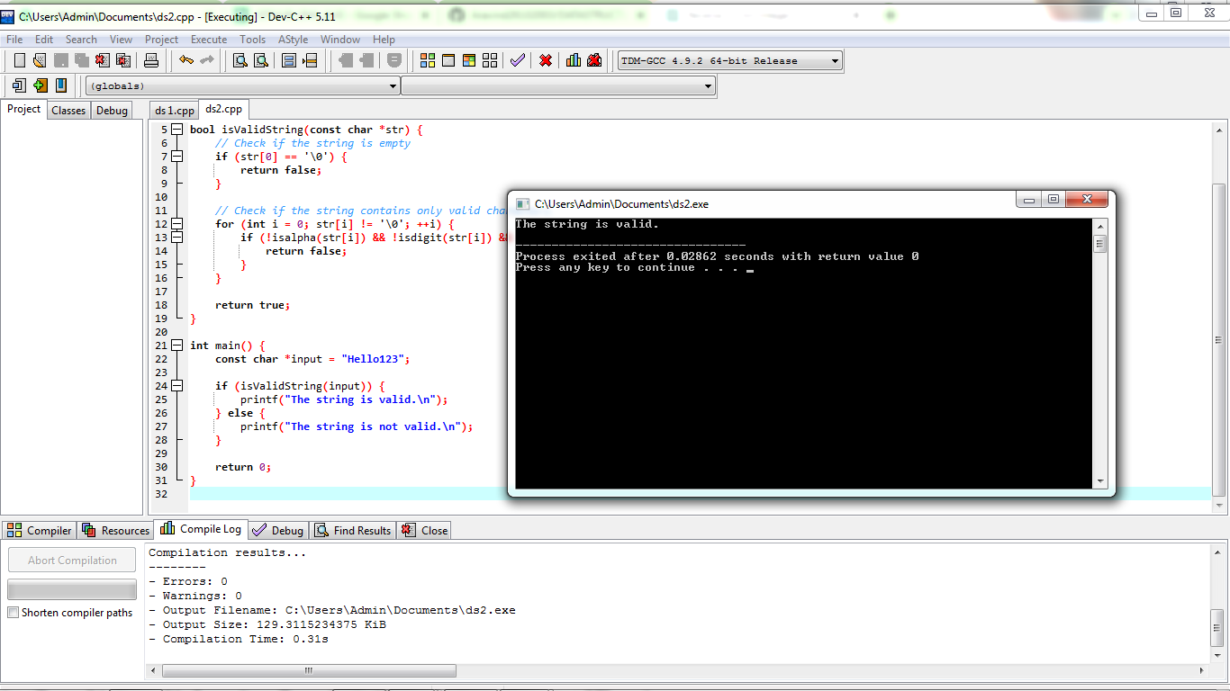

1. **Merging two Arrays**

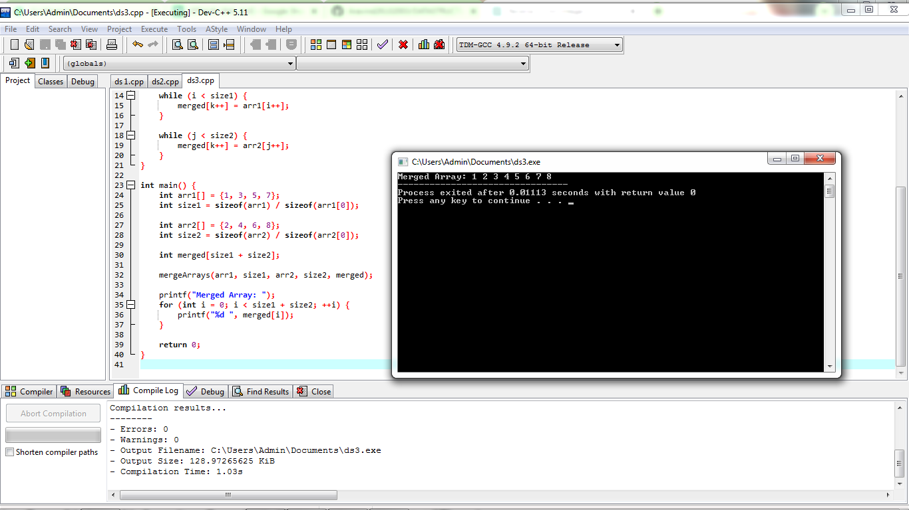

1. **Given an array finding duplication values**

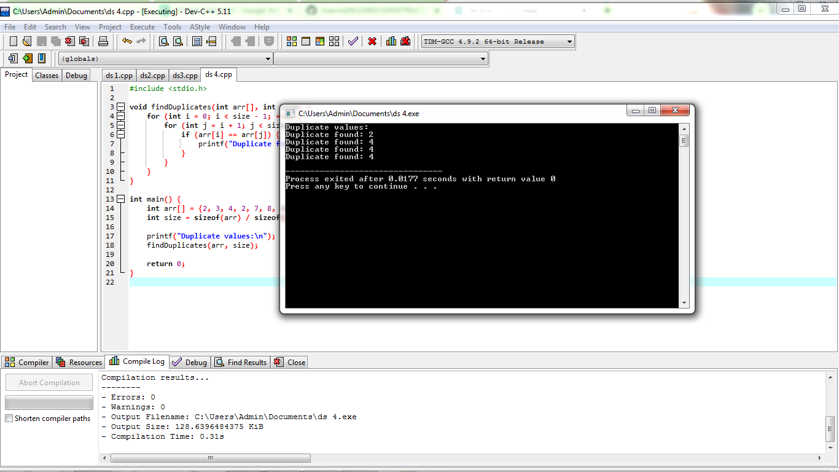

1. **Merging of list**

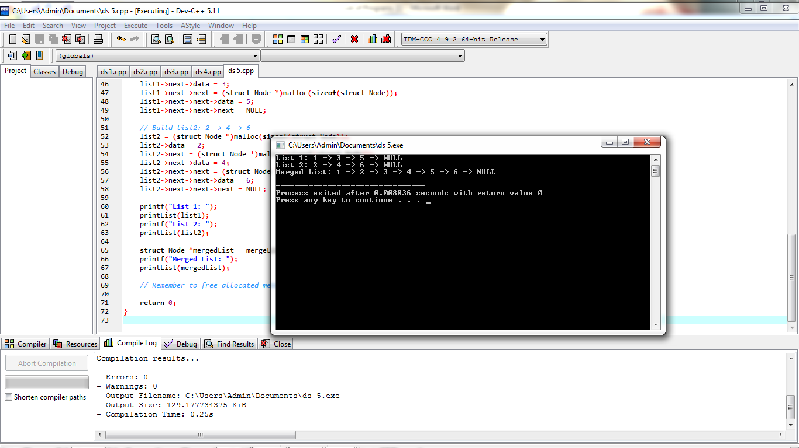

1. **Given array of reg nos need to search for particular reg no**

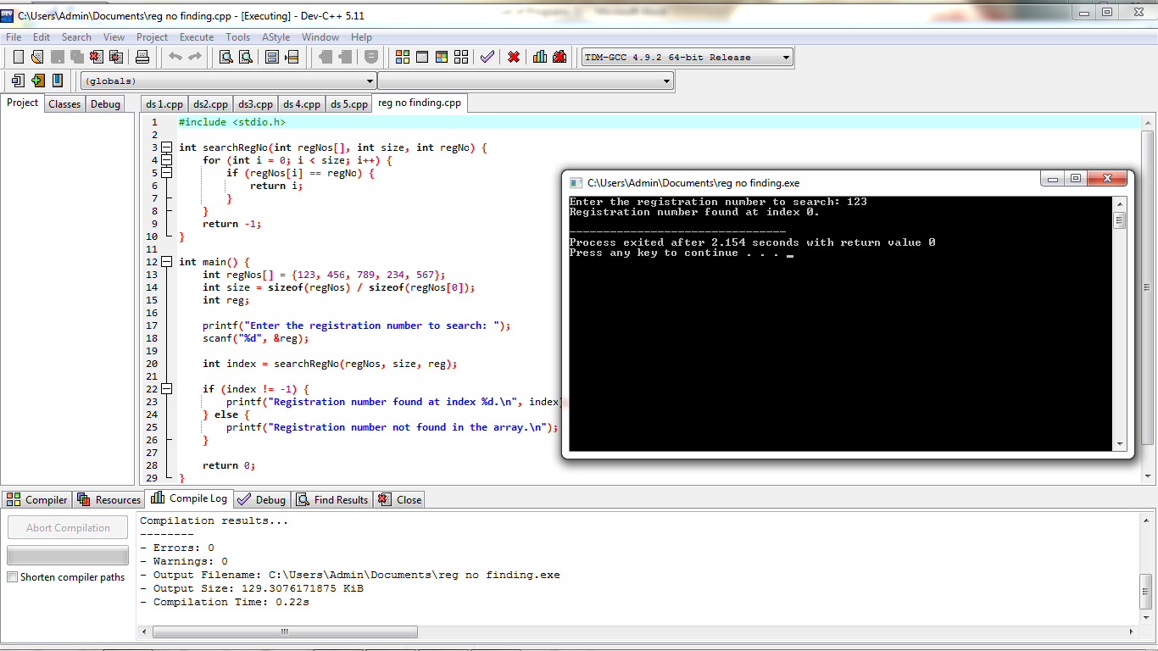

1. **Identify location of element in given array**

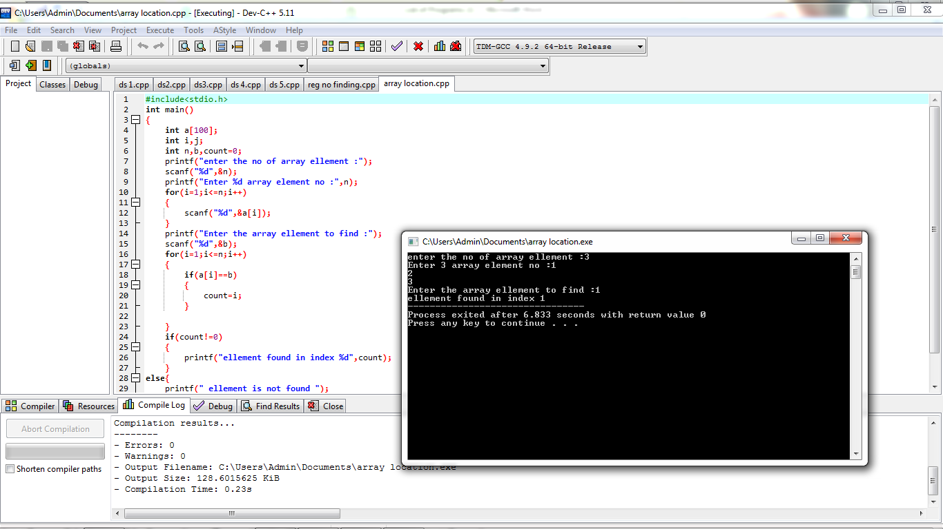

1. **Given array print odd and even values**

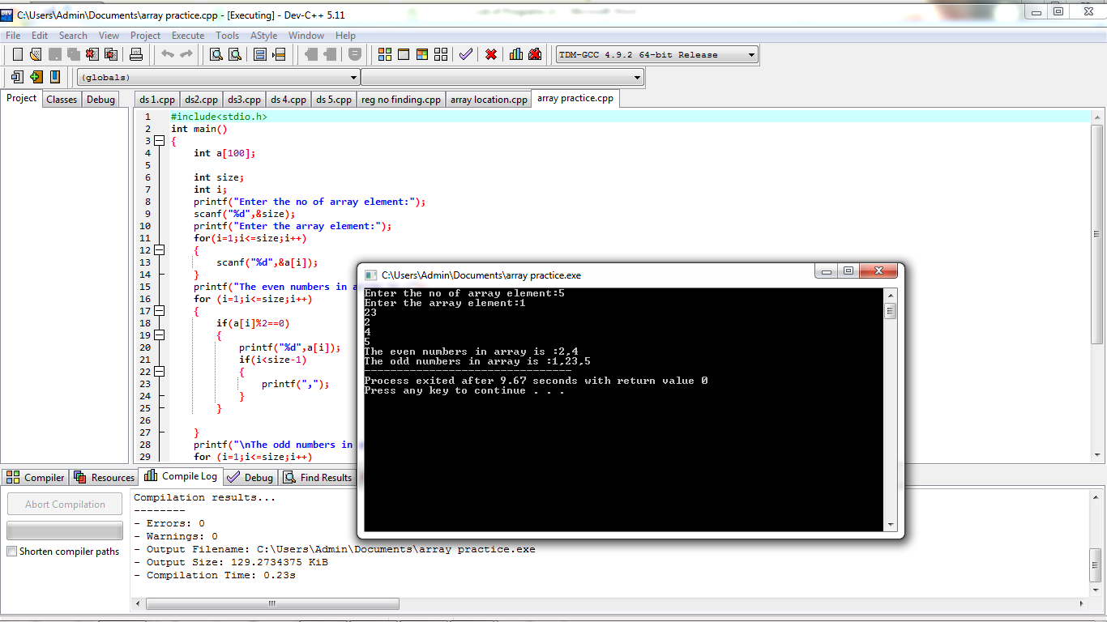

**9.sum of Fibonacci Series**

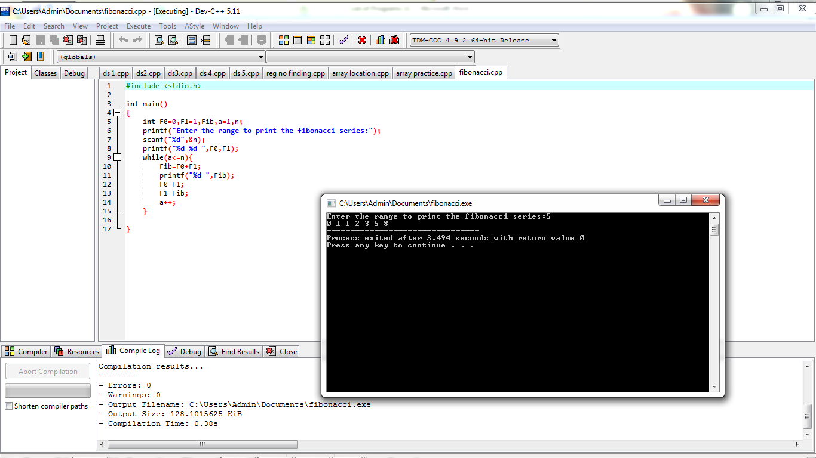

**10.Finding factorial of a number**

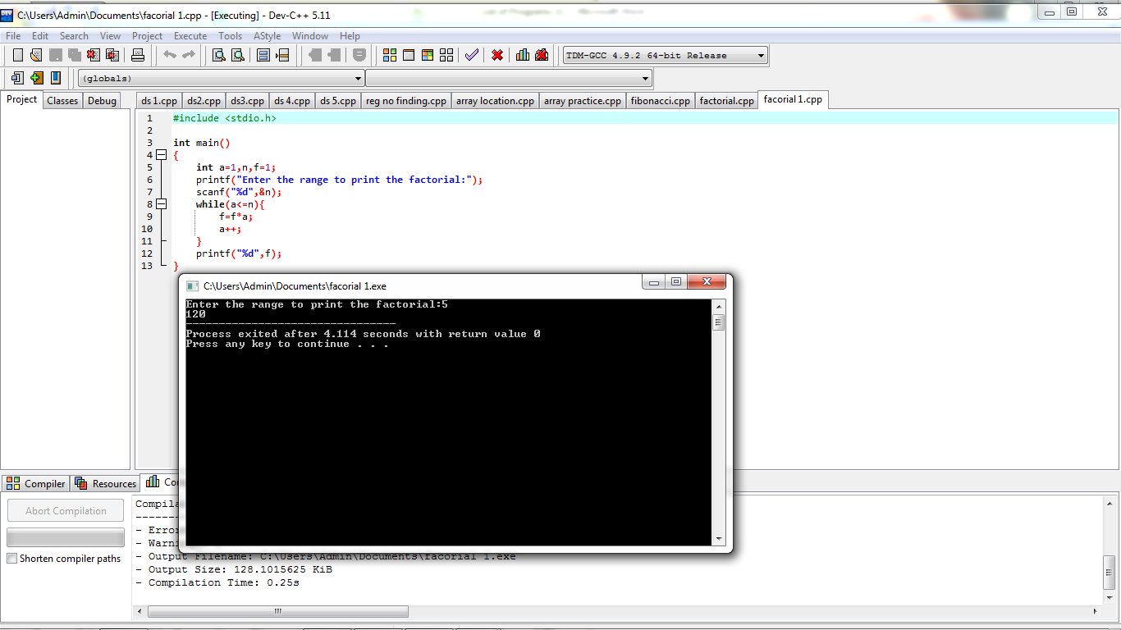

**11. AVL tree**

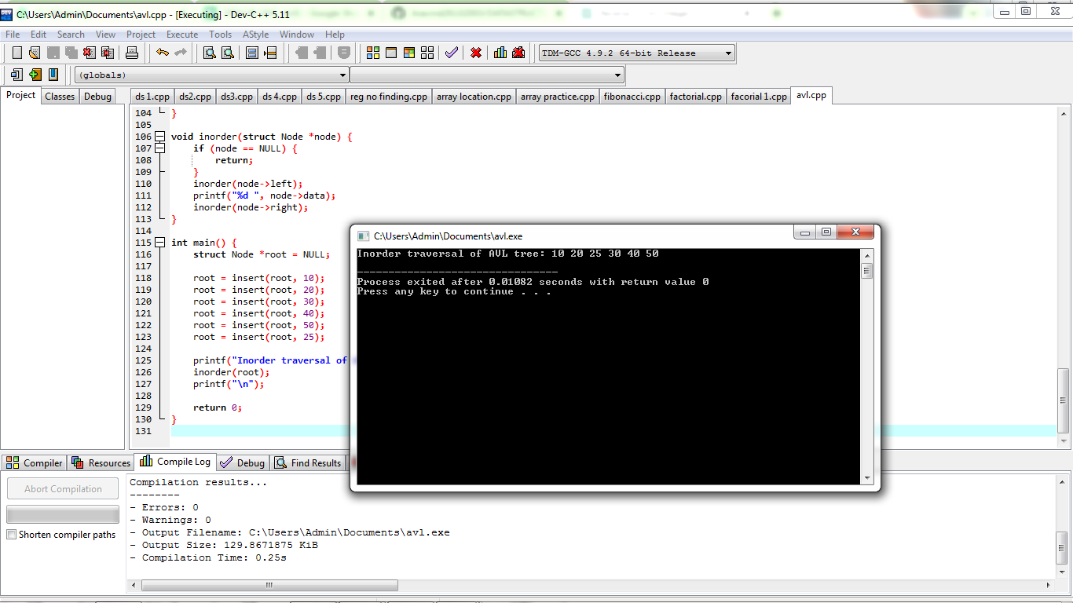

**12. Valid stack**

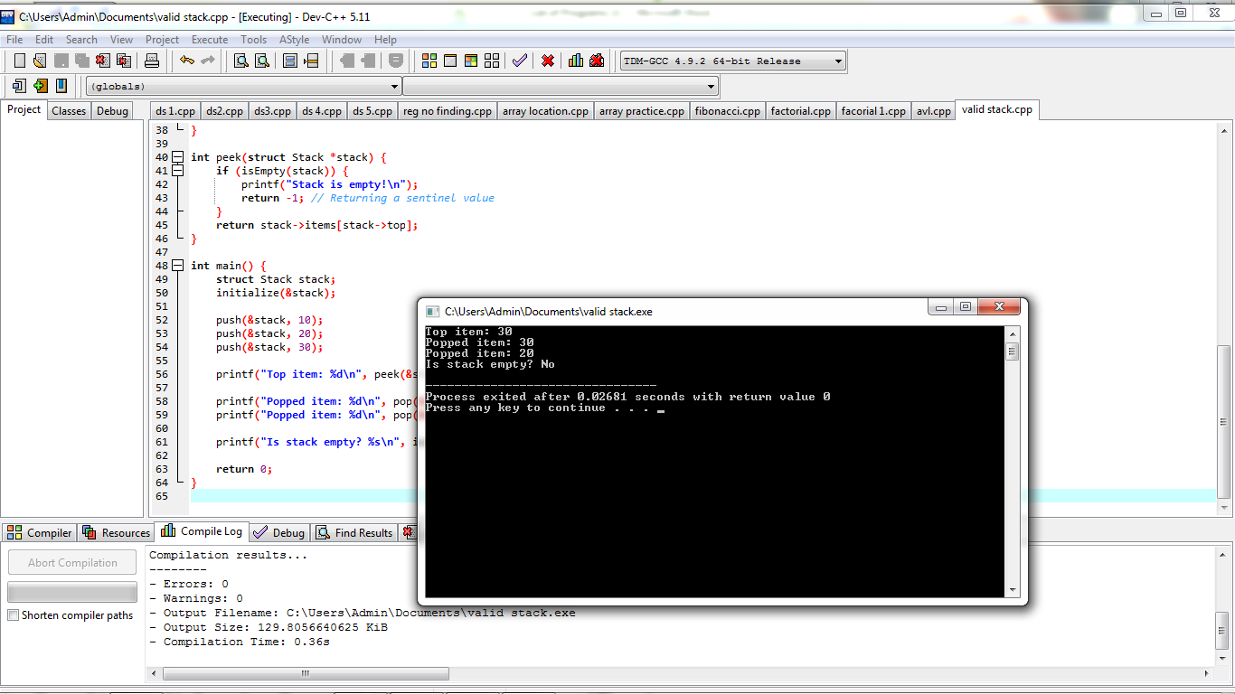

**13. Graph - shortest path**

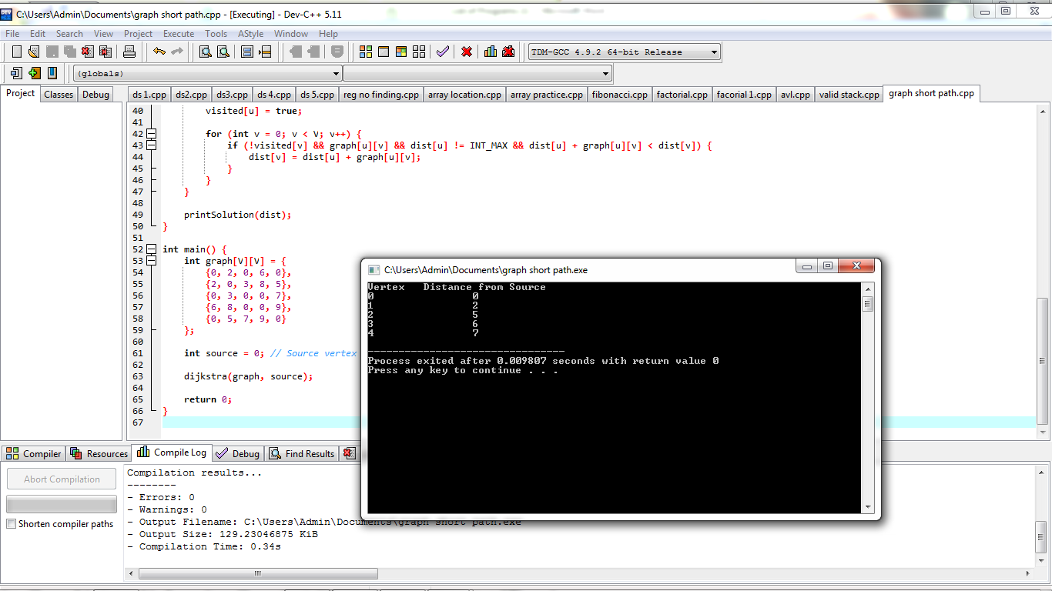

**14. Traveling Salesman Problem**

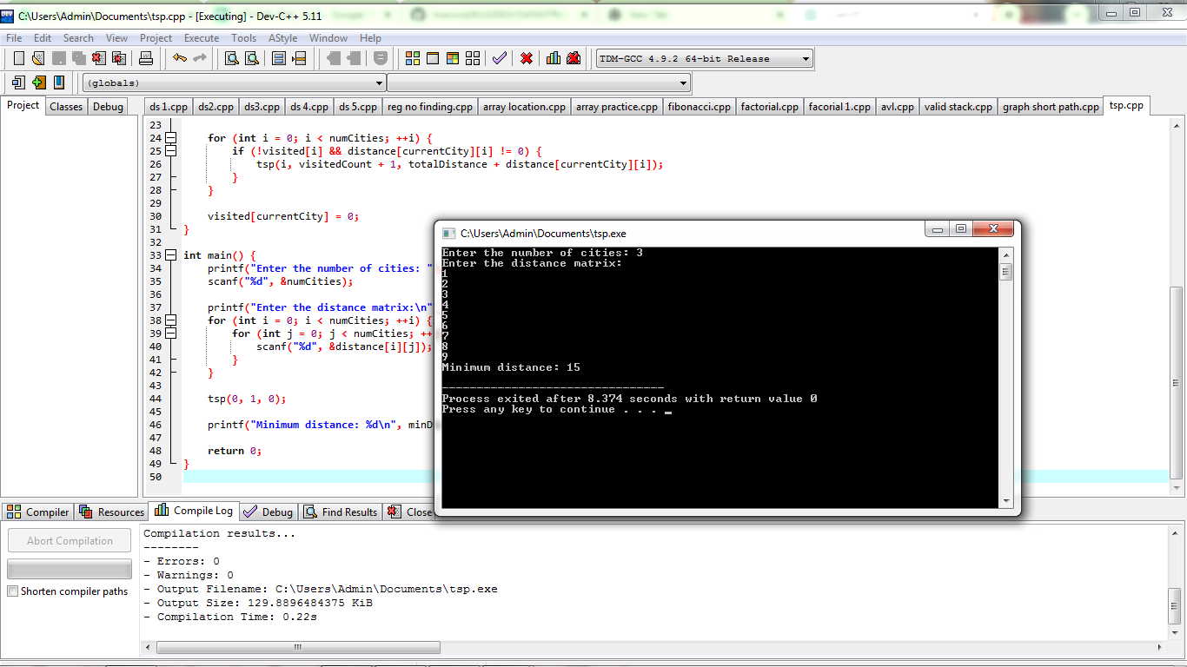

**15.! Binary search tree - search for a element, min element and Max element**

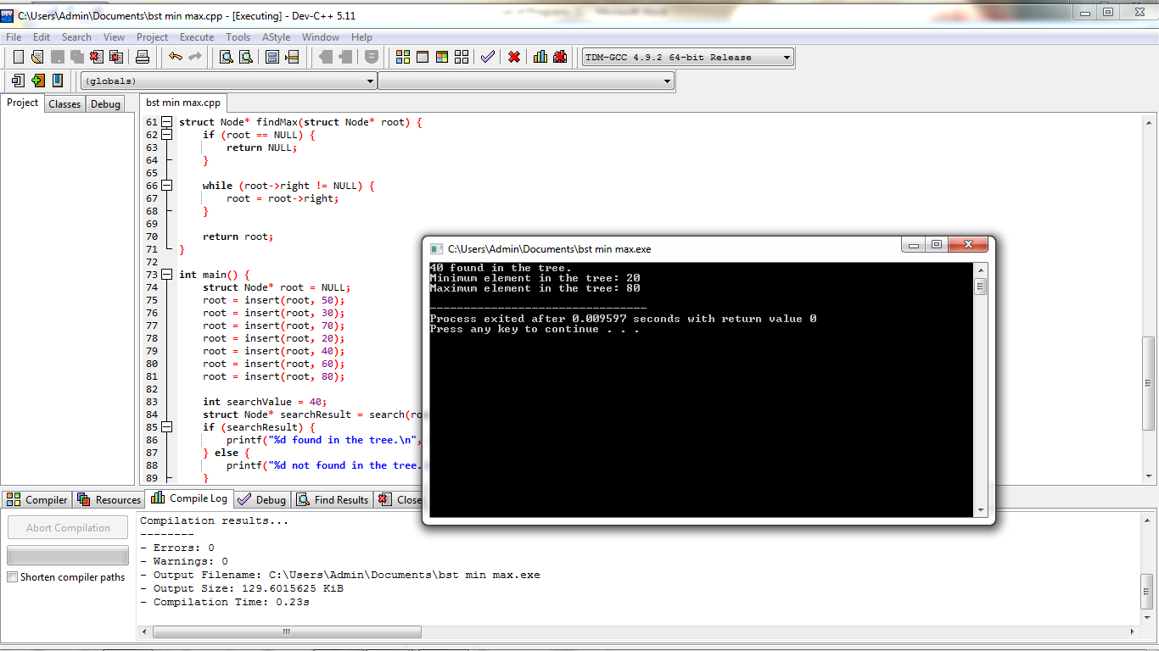

**16. Array sort - ascending and descending**

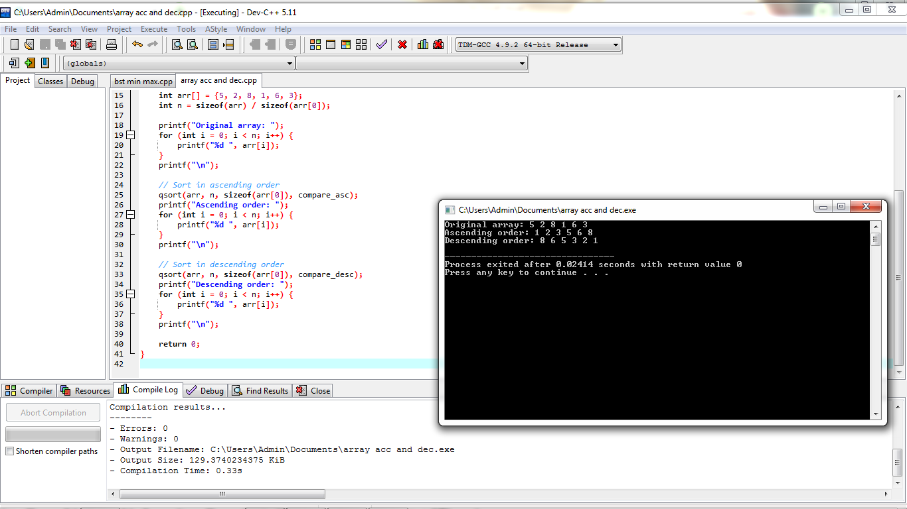

**17 Array search - linear and binary**

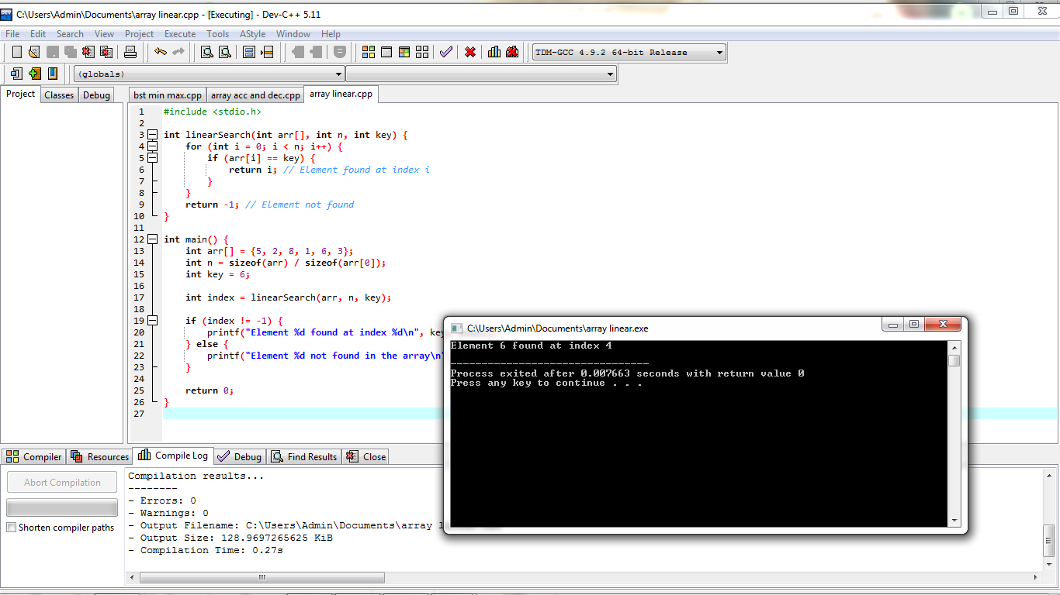

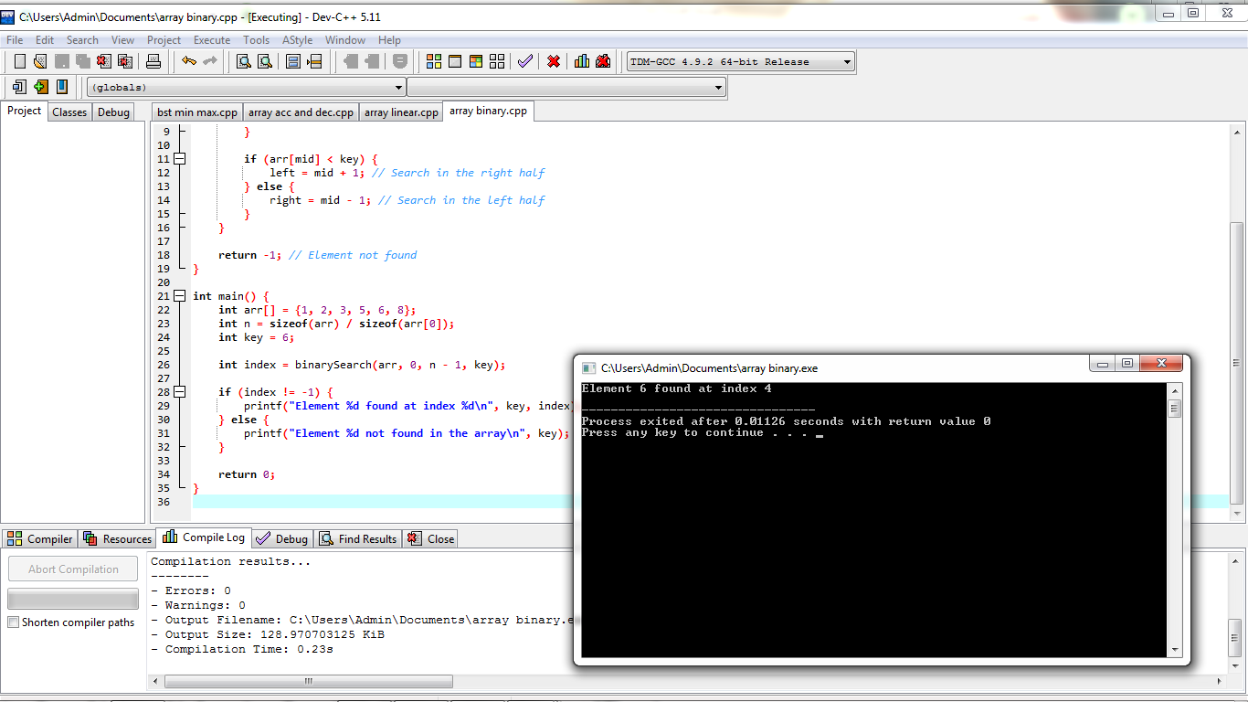

**18. given set of Array elements - display 5th iterated element**

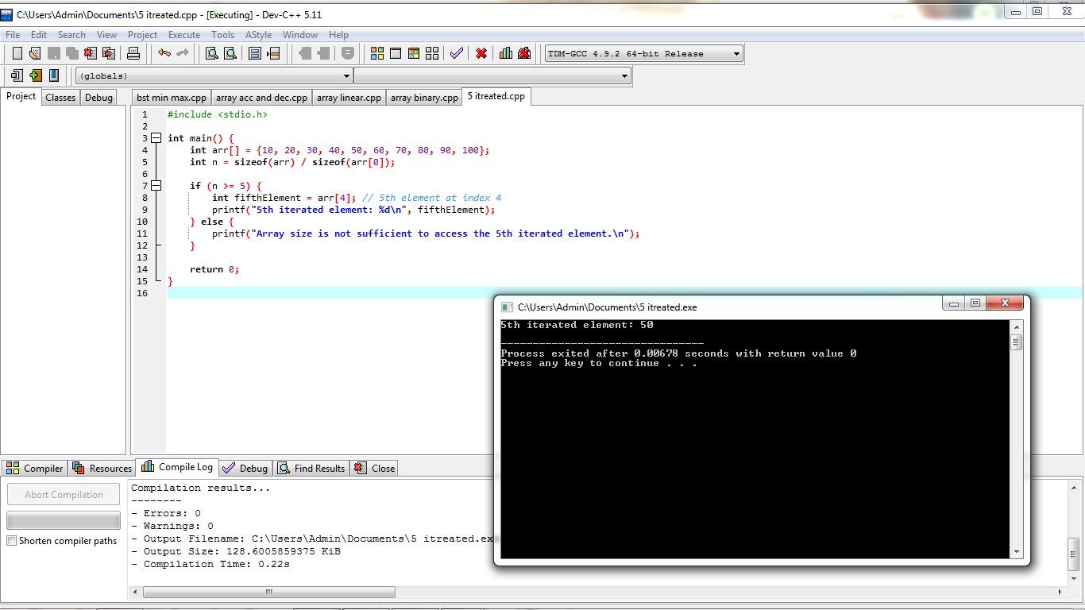

**19. Given unsorted array - Display missing element**

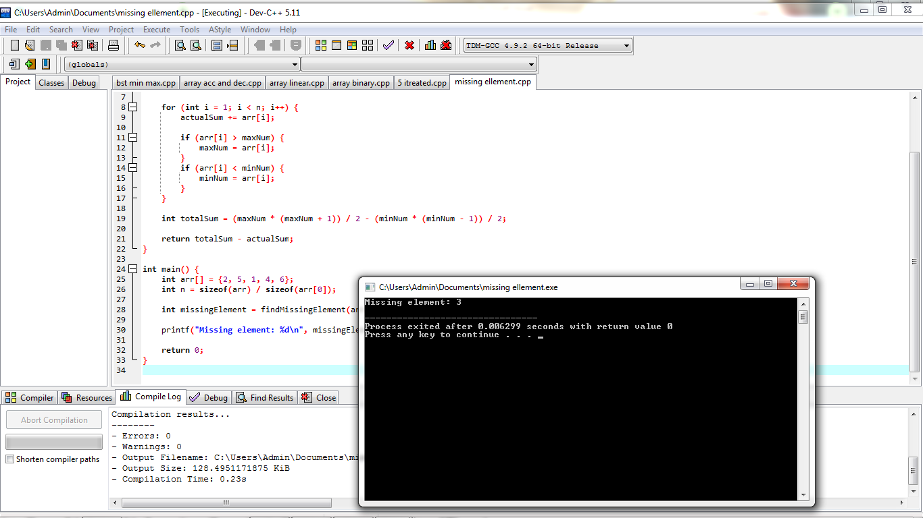

**20. Array concatenation**

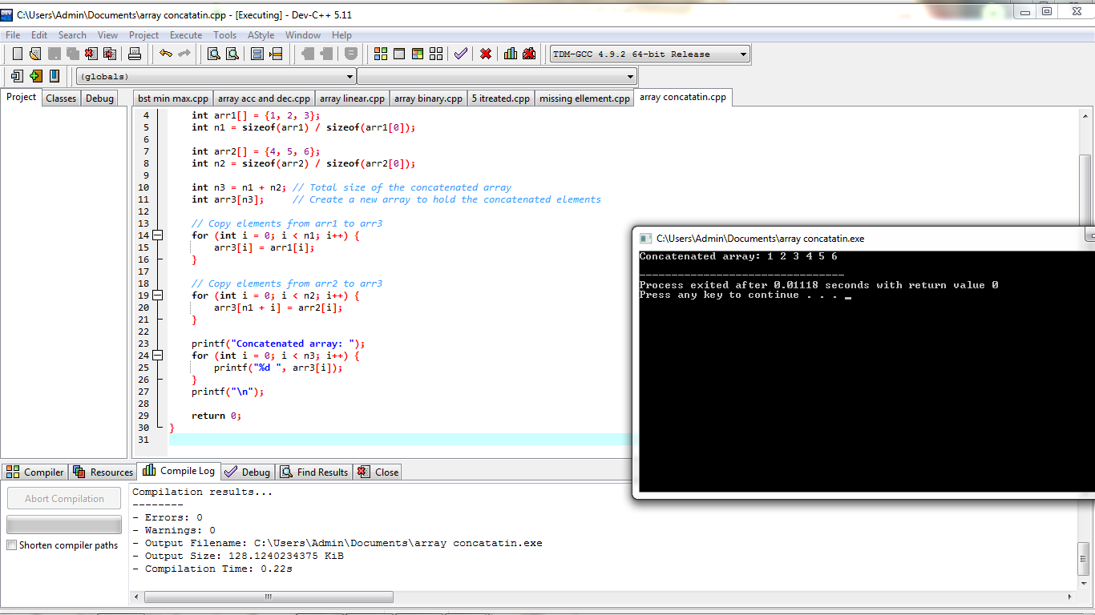

**21. Haystack**

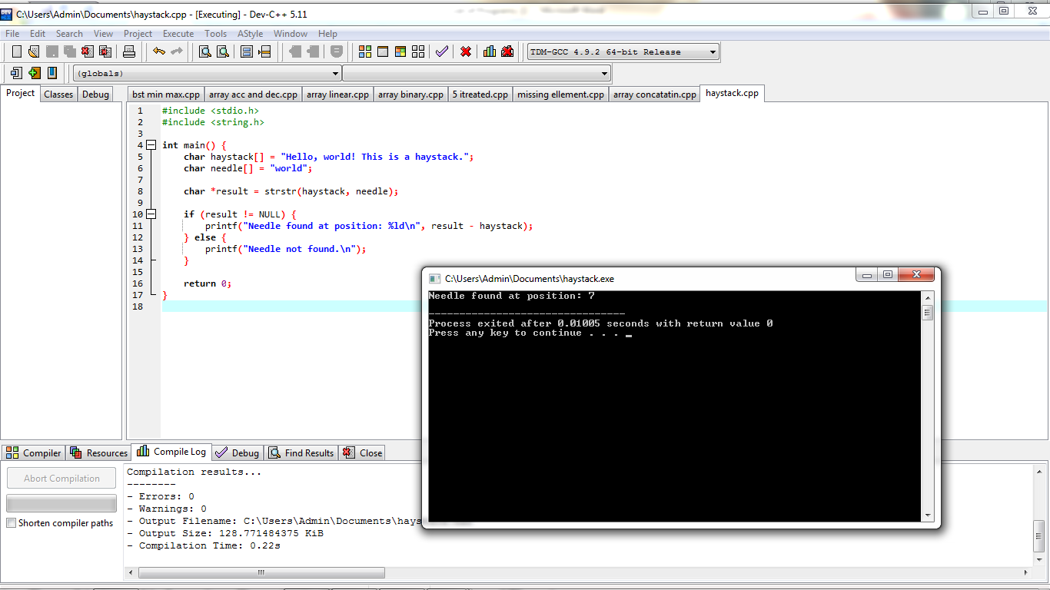

**22. Given Graph convert to array and print minimum edges**

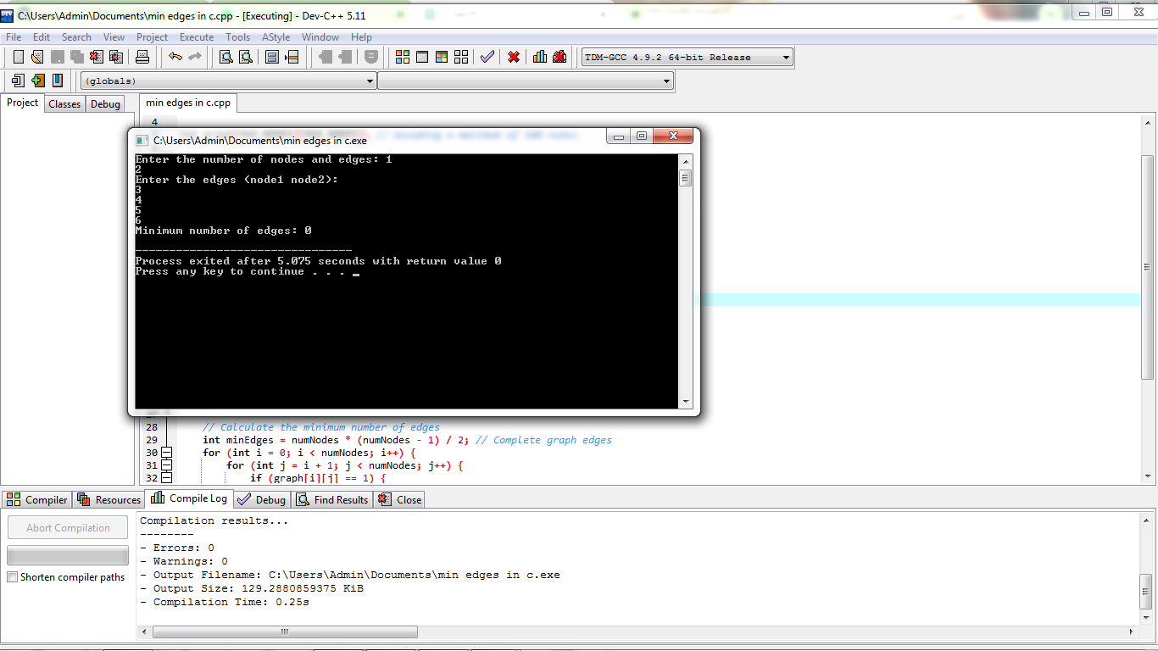

**23. Given Graph - Print valid path**

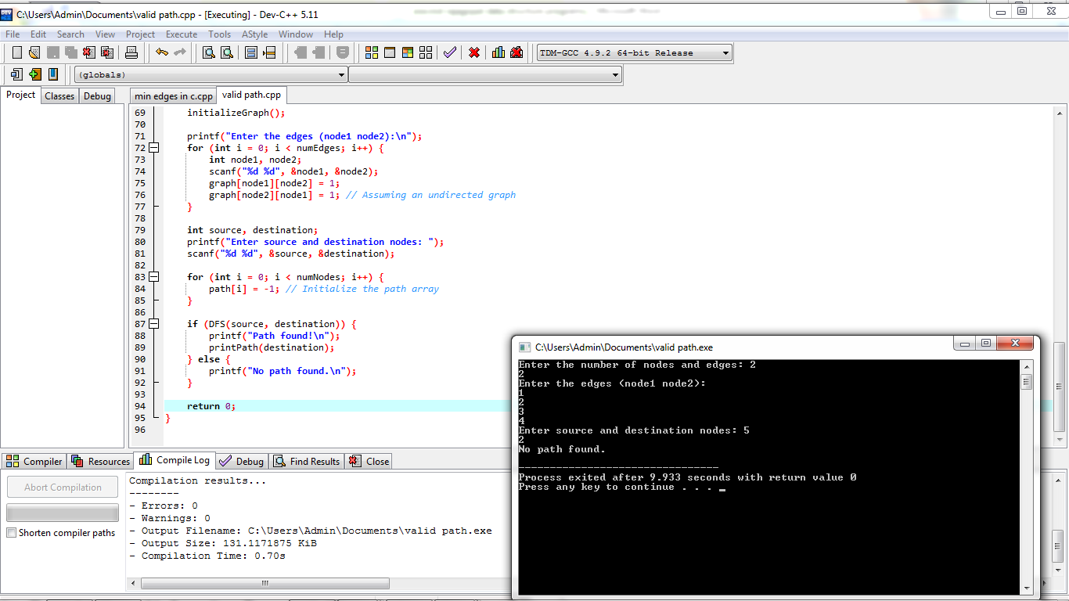

**24, heap ,mege, insertion and quick sort**

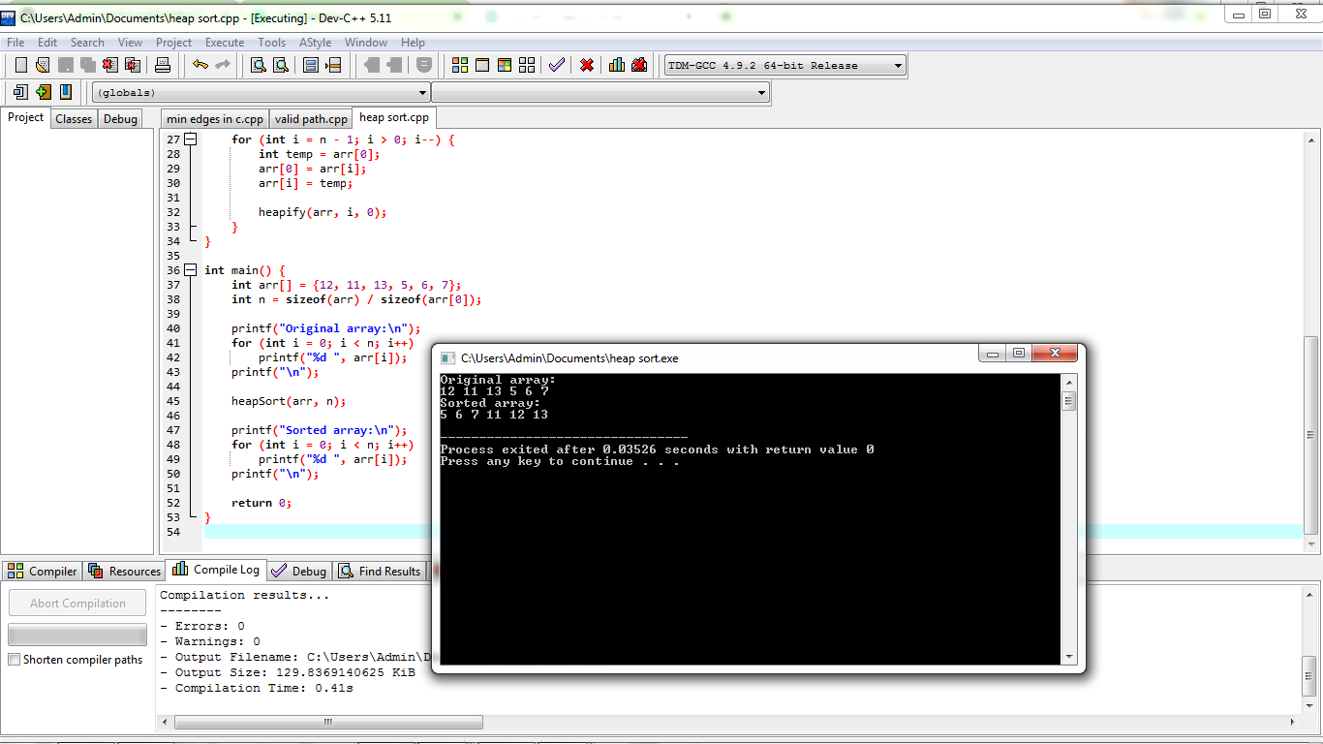

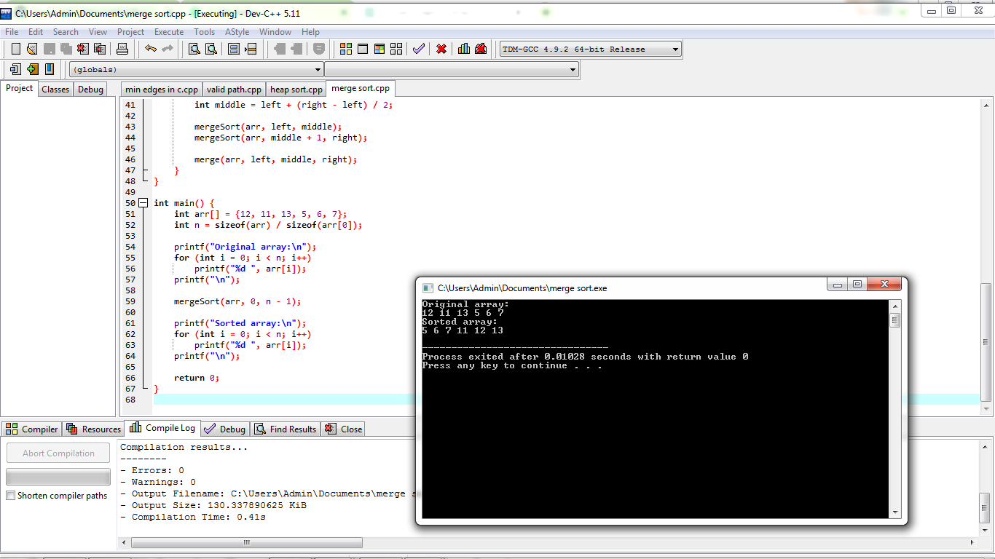

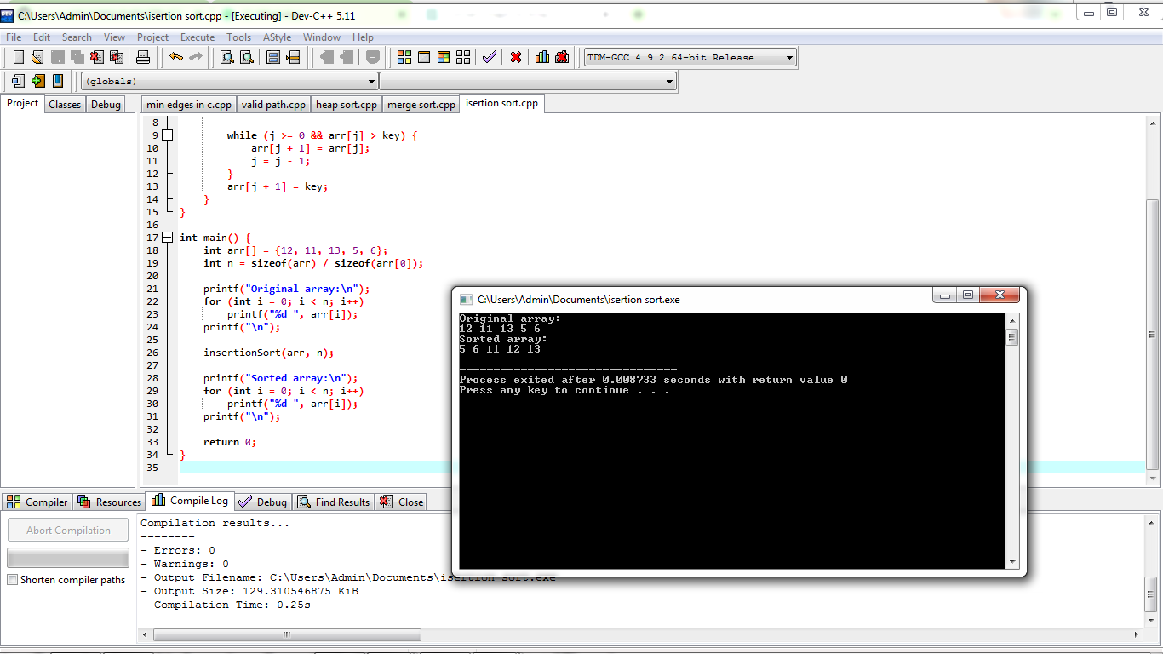

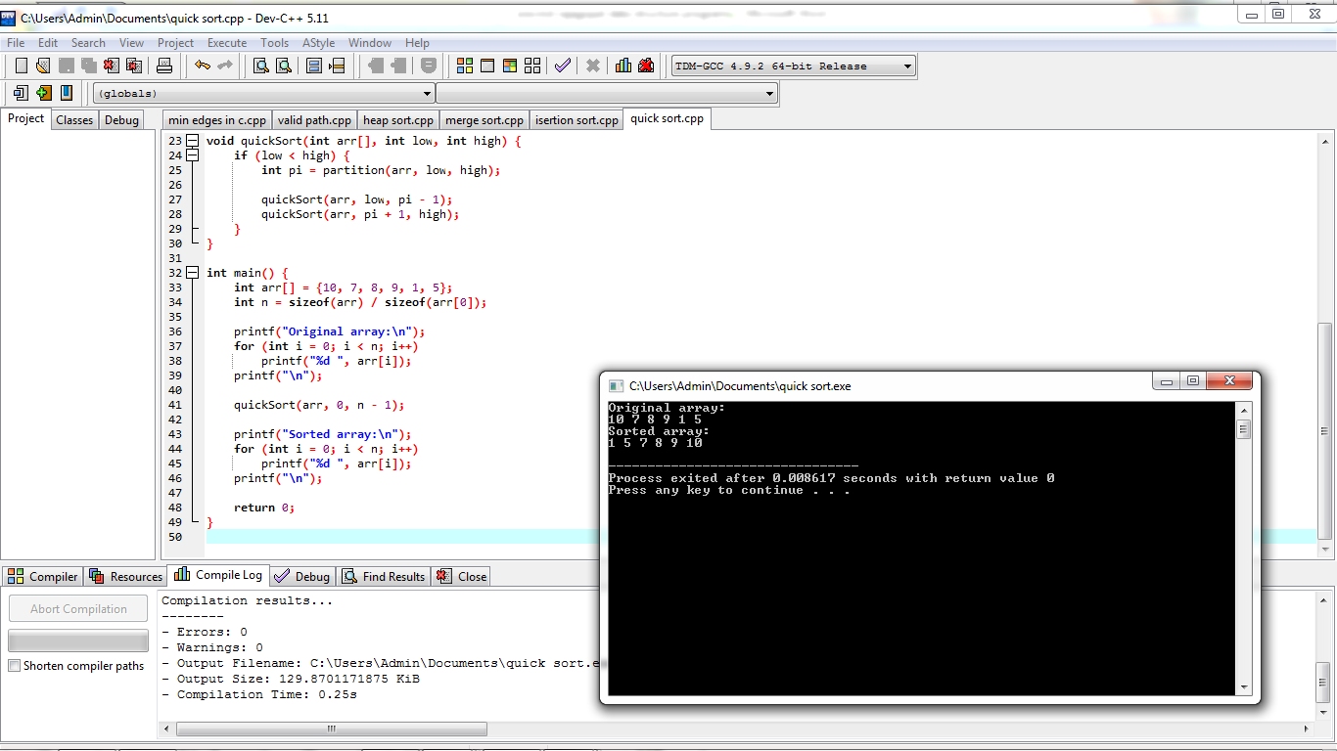

**25. Print no of nodes in the given linked list**

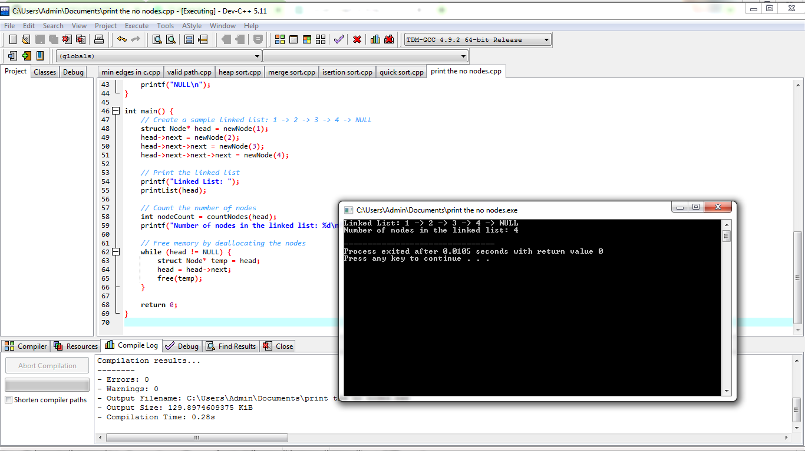

**26. Given 2 D matrix print largest element**

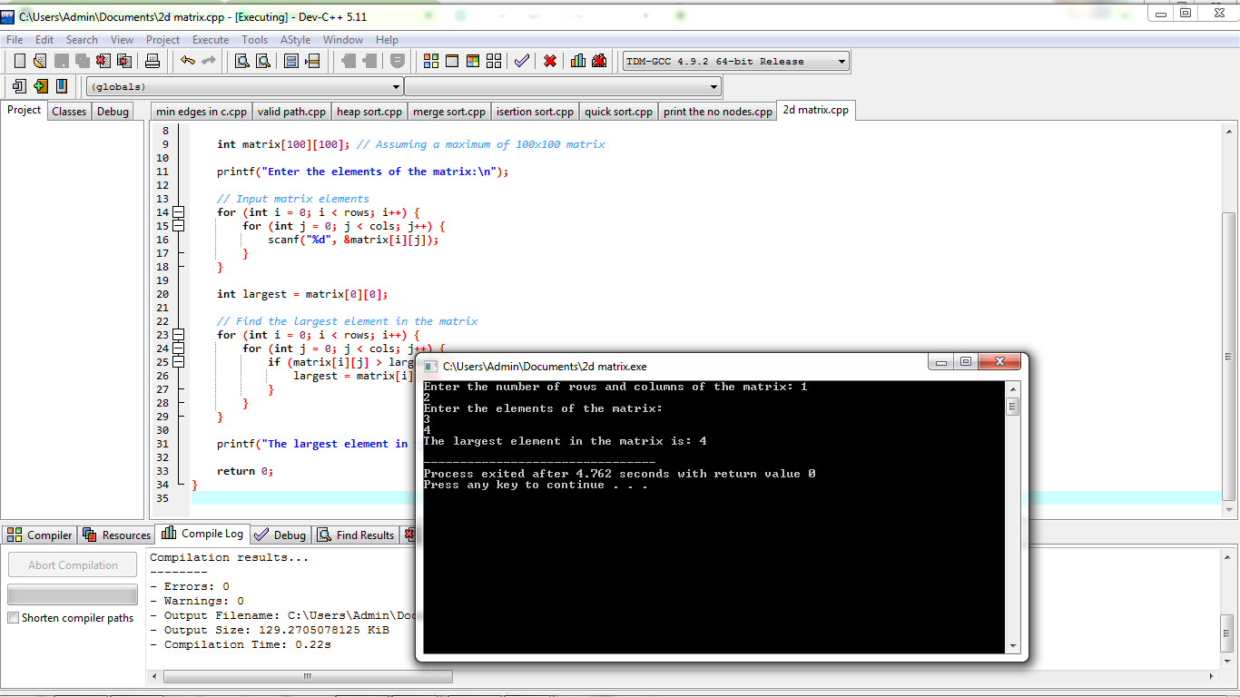

**27. Given a string - sort in alphabetical order**

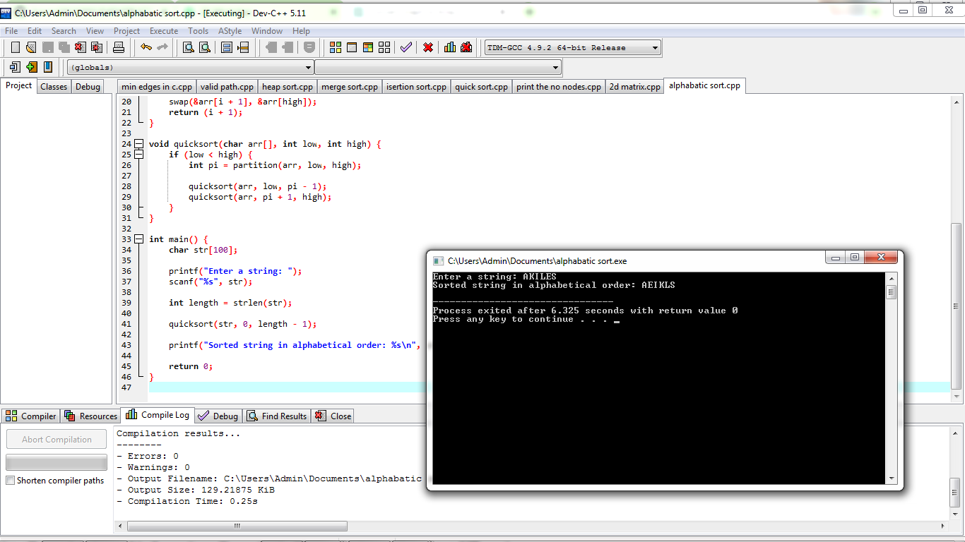

**28. Print the index of repeated characters given in an array**

